**Milestone 2 - MVC**

***Xcode Project "Personal"***

Create a new Xcode project consisting of an iOS *Single View Application* called **Personal**. When you set up the project, make sure the Organisation Identifier is set to **au.edu.griffith.ict.prog**, the **language is set to Swift**, and Devices is set to **Universal**! After clicking **Next**, select the **Desktop** folder to create your project in and make sure you select **Create local git repository for this projec**t, before clicking **Create**.

***Tests First***

Download **PersonalTests.swift**, the test code for your model (see the **Attached Files** download link, either at the top of the Milestone (if you are on the Assignment 1 page) or at the bottom of the text (if you are on the Week 2 milestone page)), and, in Xcode, replace the content of the PersonalTests.swift file with the file you have just downloaded.  Run the tests within Xcode by selecting Product / Test from the menu at the top (or use the Command-Ukeyboard shortcut).  Make sure that the tests **fail** (*at this stage*, because you have not implemented the model yet)!

***Model: Person Class***

Add a simple **Person** class that contains two String properties, firstName and lastName, one Optional String property, middleName, and one Int property containing the age of the person (in years).  Create an initialiser that has the following signature (this is important, otherwise the tests won't work!):

init(firstName: String, lastName: String, age: Int, middleName: String? = nil)

Add a fullName() method that returns the full name of the person (as a String) in the order of firstName, middleName, lastName (or firstName, lastName if the person has no middle name), separated by exactly one space between names (e.g., for a person with a first name of John, a middle name of Paul, and a last name of Jones, the string returned from the fullName() method should be "John Paul Jones" - if the person's first name is René and the last name is Hexel, the returned string should be "René Hexel" (note that there is *only one space* between first and last name!).  The signature for the fullName method should be:

func fullName() -> String

Save your changes and run the tests again.  This time, make sure that all the tests succeed!

***View***

Edit your main story board so that the user can enter the data to be stored in an object of class **Person**.  Add a button labelled **Show the person's full details**.  Here is an image (scaled down to 50%) of what your User Interface (UI) should look like (the first image shows the empty fields, the second image shows the UI with the keyboard after the user has entered all data):

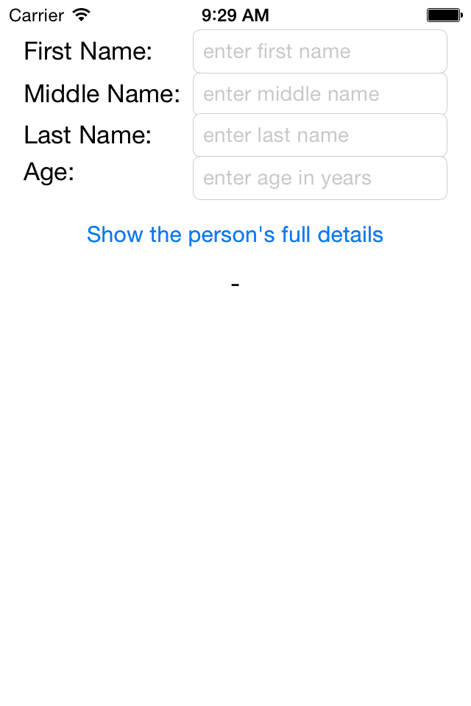 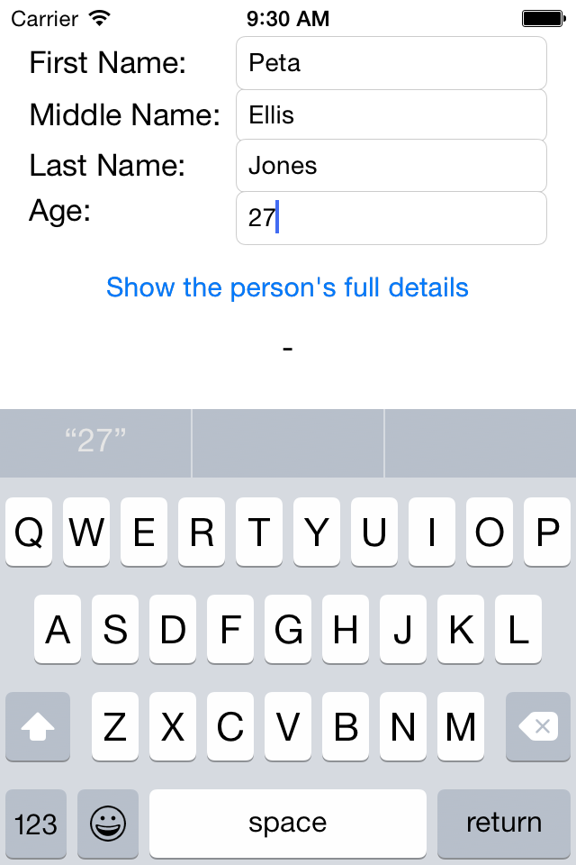

Make sure you link up outlets in your controller for the text fields to enter the data and for the label that displays the full details!

***Controller: Putting it all together***

Add code to your controller that initialises an instance of class **Person** and then lets the user update the properties (first, middle, and last name as well as age).  **Make sure that the middleName property becomes nil** when the Middle Name text field is empty!  Create an action (method) in your controller that gets called when your **Show the person's full details** button gets pressed (it is okay to only copy the person data from the view into your model when this method is called).  In this action method, display your person's full details (that you initialised before) in the order firstName, middleName (optional), lastName, followed by age on screen (using the outlets you created previously).  **Only display a single space between first and last names if the middle name is nil**, i.e.:

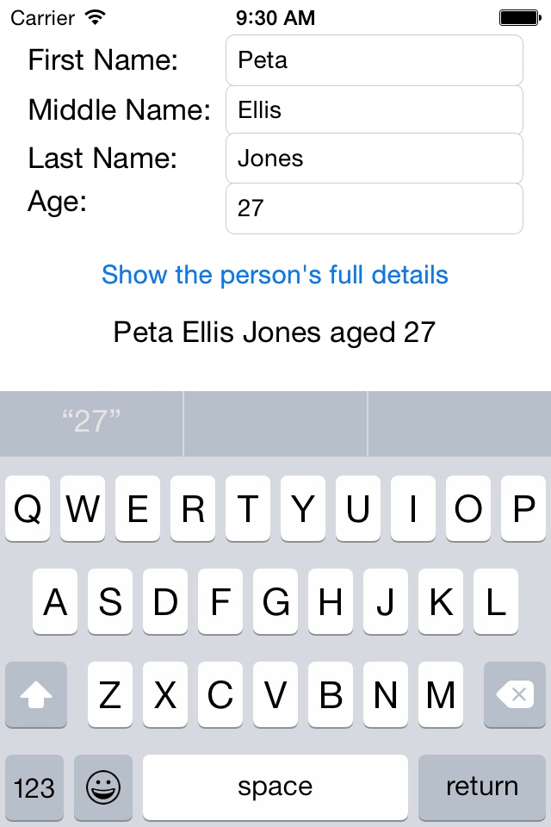 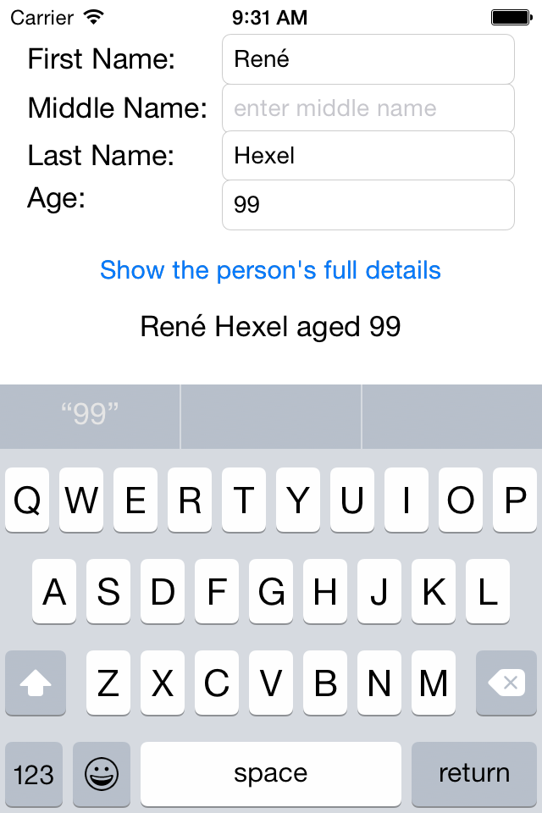

***Submission***

Zip up the folder that contains your project (i.e. if your project is called Personal, you should find a Personal folder on the Desktop). On the Mac, you can easily create a ZIP file of a folder by holding the Control key, clicking on the folder you want to zip up, and then select Compress "Personal" to compress).  Submit the ZIP file to BBlearn (click on the link that reads Week 2 at the top of this milestone page, then attach your ZIP file, and submit).